Assignment-30.2:

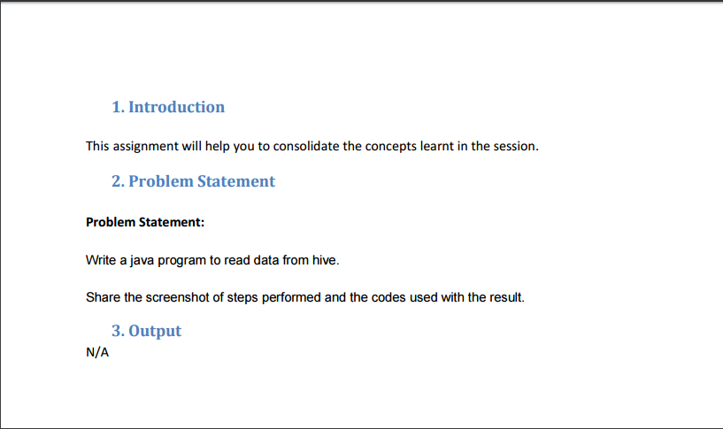

Creating a table named hive_read and displaying the contents of the table:

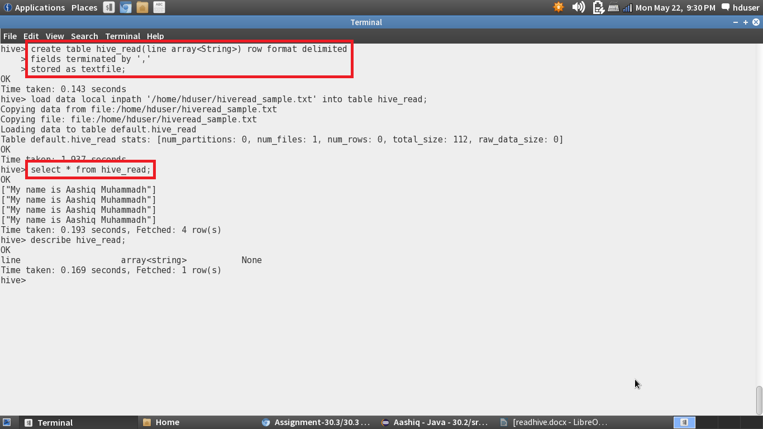

Setting the configurations in the hive-site.xml. The port number for the hiveserver 2 is set to 10000 and the mysql configurations are set.

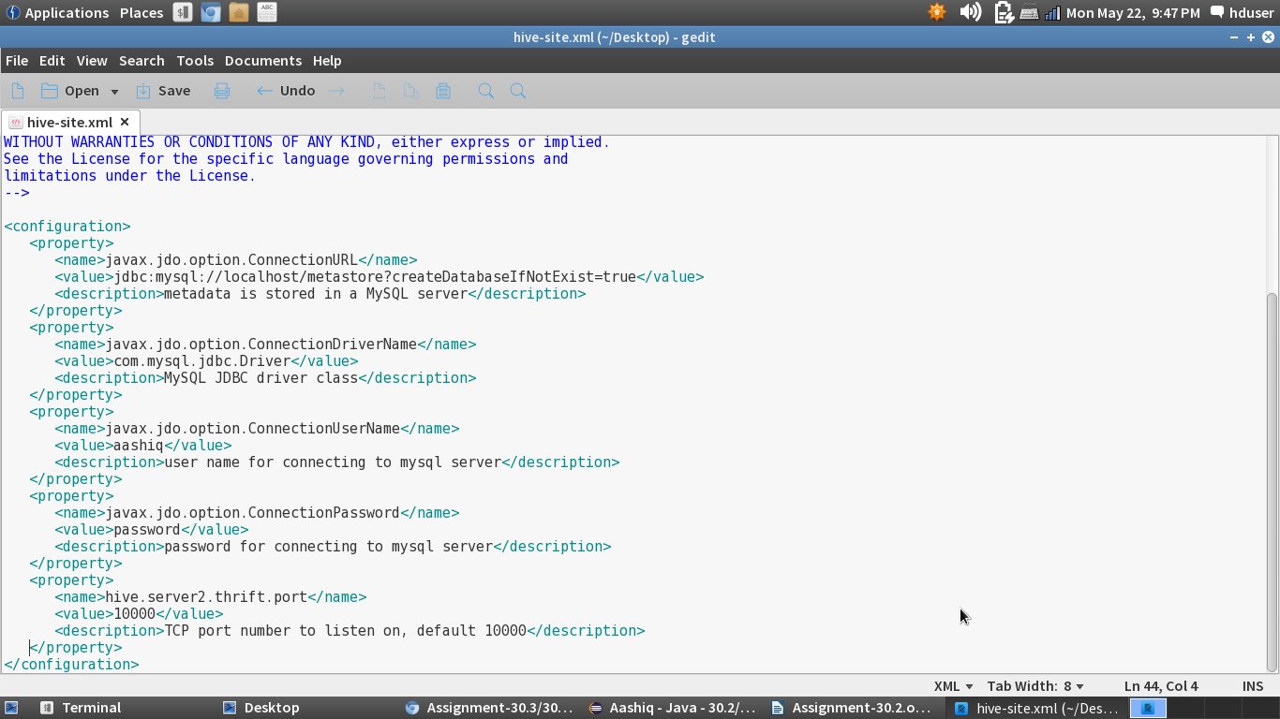

Starting the hiveserver2:

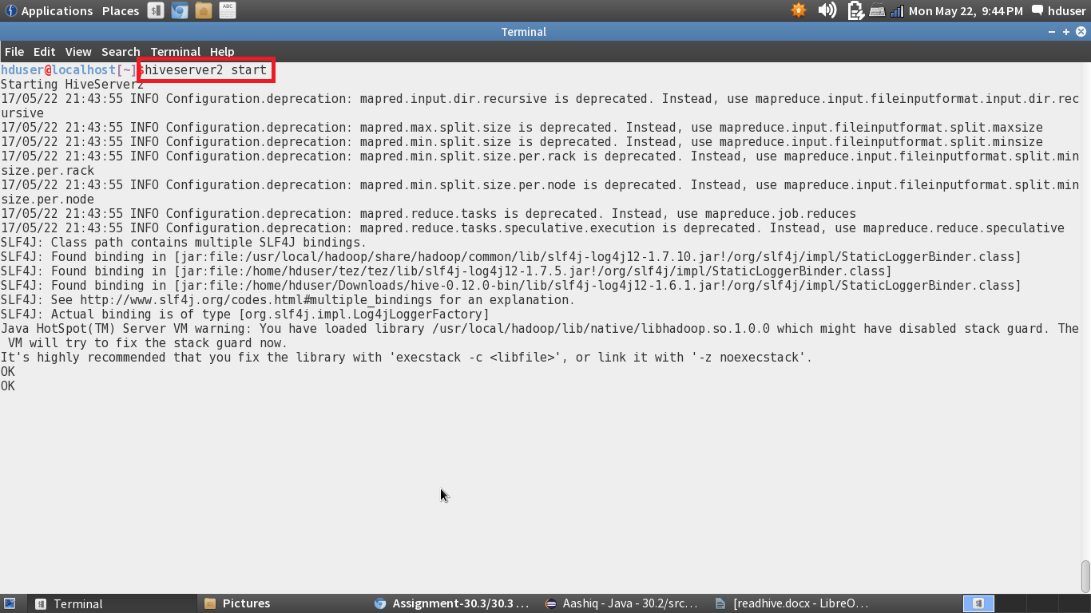

Java Program:

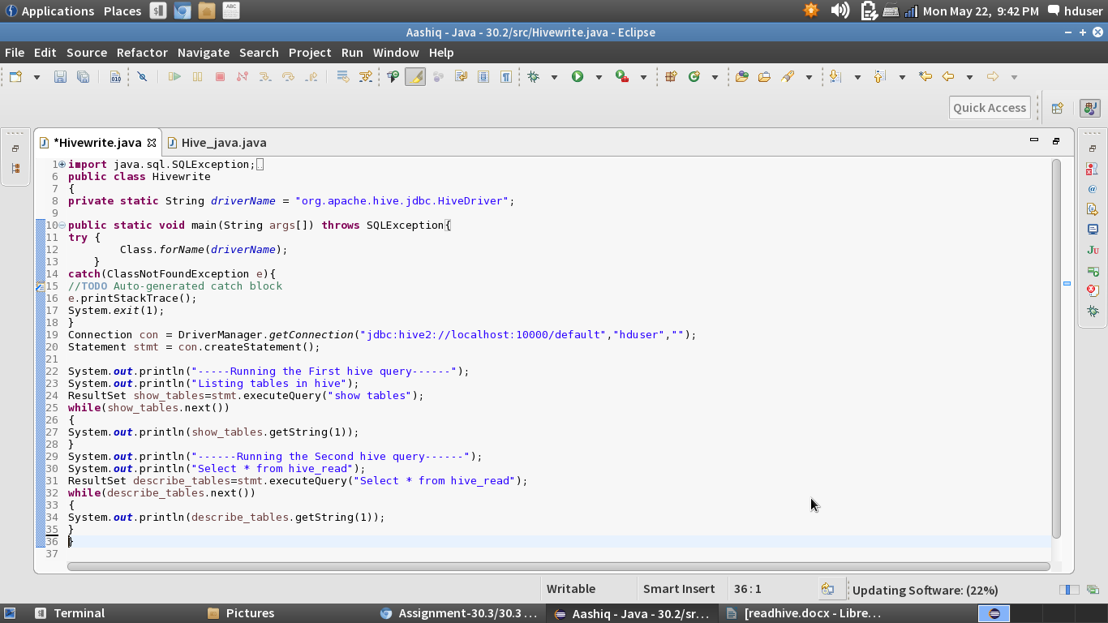

Console: The Contents of the hive table is displayed using java api:

